BRIGHTLINGSEA WEA
presents
Geoffrey Chaucer
- Civil Servant & Poet

Tutor: Graham Platts

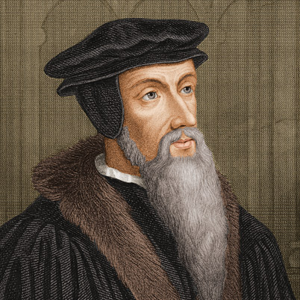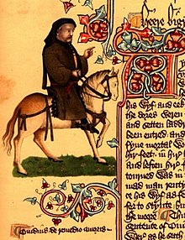

Covering Chaucer’s life, contemporary events,
ideas and literary heritage.

Commencing Tuesday 9th January, 2018
at the Parish Hall, Brightlingsea – 10 am to 12 noon

The 10 week course costs £72
Anyone on income-based benefit may be eligible to come free.

To find out more information & book a place,
please contact: Angela Wilson 01206-303551
or email: angiewilson1@btinternet.com

